Actuators in IoT

- An IoT device is made up of a:
Physical object (“thing”)
+ Controller (“brain”)
+ Sensors + Actuators
+ Networks (Internet).
- An actuator is a machine component or system that moves or controls the mechanism or the system.
- Sensors in the device sense the environment, then control signals are generated for the actuators according to the actions needed to perform.
- A servo motor is an example of an actuator.

- They are linear or rotatory actuators, can move to a given specified angular or linear position.

- We can use servo motors for IoT applications and make the motor rotate to 90 degrees, 180 degrees, etc., as per our need.
The following diagram shows what actuators do, the controller directs the actuator based on the sensor data to do the work.

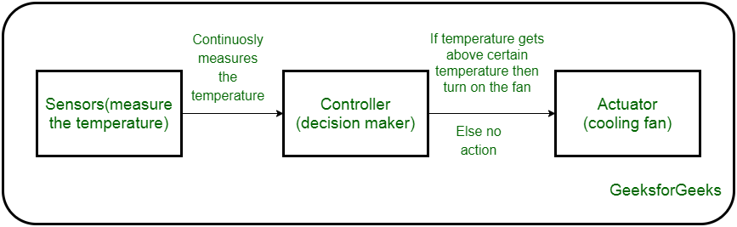
Working of IoT devices and use of Actuators
- The control system acts upon an environment through the actuator.
- It requires a source of energy and a control signal.
- When it receives a control signal, it converts the source of energy to a mechanical operation.
- On this basis, on which form of energy it uses, it has different types given below.
Types of Actuators:
1. Hydraulic Actuators –
A hydraulic actuator uses hydraulic power to perform a mechanical operation. They are actuated by a cylinder or fluid motor. The mechanical motion is converted to rotary, linear, or oscillatory motion, according to the need of the IoT device. Ex- construction equipment uses hydraulic actuators because hydraulic actuators can generate a large amount of force.
Advantages :
- Hydraulic actuators can produce a large magnitude of force and high speed.
- Used in welding, clamping, etc.
- Used for lowering or raising the vehicles in car transport carriers.
Disadvantages :
- Hydraulic fluid leaks can cause efficiency loss and issues of cleaning.
- It is expensive.
- It requires noise reduction equipment, heat exchangers, and high maintenance systems.
2. Pneumatic Actuators –
A pneumatic actuator uses energy formed by vacuum or compressed air at high pressure to convert into either linear or rotary motion. Example- Used in robotics, use sensors that work like human fingers by using compressed air.
Advantages :
- They are a low-cost option and are used at extreme temperatures where using air is a safer option than chemicals.
- They need low maintenance, are durable, and have a long operational life.
- It is very quick in starting and stopping the motion.
Disadvantages :
- Loss of pressure can make it less efficient.
- The air compressor should be running continuously.
- Air can be polluted, and it needs maintenance.
3. Electrical Actuators –
An electric actuator uses electrical energy, is usually actuated by a motor that converts electrical energy into mechanical torque. An example of an electric actuator is a solenoid based electric bell.
Advantages :
- It has many applications in various industries as it can automate industrial valves.
- It produces less noise and is safe to use since there are no fluid leakages.
- It can be re-programmed and it provides the highest control precision positioning.
Disadvantages:
- It is expensive.
- It depends a lot on environmental conditions.
Other actuators are –
  - Thermal/Magnetic Actuators
These are actuated by thermal or mechanical energy. Shape Memory Alloys (SMAs) or Magnetic Shape‐Memory Alloys (MSMAs) are used by these actuators. An example of a thermal/magnetic actuator can be a piezo motor using SMA.
  - Mechanical Actuators –
A mechanical actuator executes movement by converting rotary motion into linear motion. It involves pulleys, chains, gears, rails, and other devices to operate. Example – A crankshaft.
- Soft Actuators
- Shape Memory Polymers
- Light Activated Polymers
- With the expanding world of IoT, sensors and actuators will find more usage in commercial and domestic applications along with the pre-existing use in industry.

